# A Project Report On

EVENT MANAGEMENT

**Submitted By:**

**Abhijeet Mallik (39)**

**Lalit Rajawat (07)**

**Shashwat Dubey (29)**

**First Year Undergraduate In**

**Computer Science & Engineering**

**(I–Semester)**

**Lovely Professional University**

Phagwara, Punjab (India)

**Academic Year:**

2022-2023

Acknowledgement

First, we would like to thank our professor, Dr. Mohammad Faiz, who served as a constant source of inspiration. He challenged us to be creative thinkers and exhorted us to do this endeavour without hesitation. We were able to successfully finish this job thanks to his extensive knowledge, experience, and professional skills. Without his assistance and direction, this endeavour would not have been possible. Without the support of each and every person, this project would not have been a success. We were friends till the bitter end because we were always there to support one another.

I would want to express my gratitude to The Lovely Professional University for giving me the chance to work on the HTML website project (Event Management).

**ABSTRACT**

Even the title of the issue, event management, seems difficult. a notion that didn't really take up in India till the late 1990s. To organise any kind of event, commitment, leadership, and mental and physical devotion are essential. Regardless of the nature or scope of the event, there is hardly any change in the amount of mental and physical effort required.

Although Indians have been planning wedding ceremonies, naming rituals, and threading ceremonies since well before independence, this concept is comparatively fairly new to India. However, due to improper material handling and forecasts, they frequently encountered issues like food waste brought on by fewer visitors or a pandal fire.

The crowd has a lot of power to make the event a success or a failure. The audience judges the event in about five minutes, determining whether the almost three to four months of preparation and the labour of 70 to 80 workers were worthwhile. As a result, their efforts are always at risk up until the actual event.

There are countless tasks that need to be completed. The initial stage is to first create committees, then assign various tasks to each committee. All of the theoretical principles that were previously learned in classes on subjects like human resource planning, public relations, logistics, human skills, controlling, accounting, and others are put to use in this situation.

As an event manager one must have a lot of flexibility in terms of working pattern.

###### INTRODUCTION

You would have always been amazed at how well-produced shows like the "Filmfare" Awards, music concerts, and beauty pageants were put together. From the moment you walk through the door to the moment you leave, every last detail has been meticulously planned. That's event management for you, I suppose.

It involves mixing with the elite of the city's crème de la crème stratum, making it one of the fastest growing and most glamorous occupations today. The most complex kind of advertising and marketing is event management, which is a glamorous and exciting career. It offers a really good chance for one to fully express their creative capabilities. It requires a lot of hard work and effort but also provides great rewards.

Mega exhibits and events are frequently held, and the multi-million dollar, fast expanding event management sector. Surprisingly, no systematic research has been done to examine the expansion of this industry. The MICE (Meetings, Incentives and Events) sector of the industry covers exhibitions, conferences, and seminars, in addition to live music and sporting events.

The field of event management is glamorous and thrilling, but it also requires a lot of drive and dynamism.

Although some could argue that these are two different sectors, the logistics side of the business is paid less than the sales/sponsorship side.

**The Event Proposal**

An event firm frequently finds work by responding to a call for bids. Sometimes it's the only way for a brand-new event company to join the market. Law requires government and semi-government businesses to advertise for bids for the materials and services they demand. To ensure they are receiving competitive quotes, the majority of private enterprises will do this as a matter of good business practise. The event business is similar. A company that organises events will create bid documents similarly to any other provider. They might be added to a preferred supplier list and frequently invited to submit a tender depending on the calibre of their work.

Below is a checklist of what could be contained in the event proposal.

* Cover Letter
* Title Page
* Proprietary Notice - cautions about unauthorized disclosure
* Table of Contents (TOC)
* List of Abbreviations
* Executive Summary
* **Body of Proposal:** 
  + Profile of the Event Company:
    - General: including mission, background, credentials
    - Specific: including previous similar events and resources available
  + Project partners and their profiles
  + Event Specific information:
    - Objectives
    - Scope of Work
    - Stakeholders
    - Themes, design and ideas
    - Site/venue assessment
    - Resources required: AV, entertainment, catering, staff, suppliers...
    - Marketing and promotional services needed
* **Venue /Site Map**

All events, with the exception of cyber activities, must take place in three dimensions. Although it seems obvious, it is simple to overlook. The venue for the event has the potential to both present issues and possibilities in plenty. The venue for the event is given top attention by every event organiser. The majority of event managers won't submit a bid for an event unless they have carefully examined the venue. To make sure that nothing is forgotten, experienced conference planners will spend a few days at the conference hotel.

**Planning and Control Documentation**

It is one thing to plan the event it is another to communicate this plan to the various stakeholders. Correct event documentation is vital to effective management. The advantages are:

* It communicates the plan of the event to the staff and volunteers
* The documents provide an ongoing record of the event's progress
* They provide a history of the event planning which may be used in any liability issues
* They provide a written basis on which to improve the methods of event management
* By standardizing the documents, different events can be compared
* The production of the documents creates a discipline in the planning
* The documents impersonalize the plan - that is it takes it out of the hands of any one person and it becomes separate from any individual.
* The documents proved a link to other departments within a corporation such as finance and with the sponsors.

What will happen if the event organiser becomes sick? (A common phobia in event management is being "run over by a bus"). This risk exists as long as the specifics of any incident are only in one person's memory. Various schedules, responsibility and action sheets serve as documentation for the outcomes of the project management process. Each event firm has developed its own distinctive style of sheets.

1. **EVENT CONTROL**

**Negotiation**

An event is a singular occurrence, even though this seems clear. The yearly festivity changes every year. The administration of events must accommodate change. Change will need developing new business partnerships for each occasion. As a result, bargaining abilities are crucial to event management. Negotiation does not imply shady dealings; rather, it refers to reaching a mutually beneficial business agreement.

A large part of event negotiation concerns the resources used to create the event. They can be divided in to:

**Standard resources** - the negotiation for standard resources is fairly straightforward as most of the constraints and parameters are already known. For example in hiring a venue there will be a standard contract. The event manager needs to know the contract terms and the history of the use of these resources at events.

**Customized resource**s - these are specialist resources created for the specific event. There may not be a standard contract or process. In this case the negotiation has to be well researched with risk and contingencies thought out. An example of this is the harbour floats for the Sydney's New Year's Eve event.

* **The Event Manual**

The manual can act as a record of the procedures as well as a list of steps to follow in order to successfully prepare and carry out the event. It is a component of an event organization's intellectual property. The systematic planning of event operations can benefit from the discipline required to create a manual. Many big businesses have a general operations and logistics manual that can be applied to events of a similar nature held all over the world. The exhibition business has produced the most thorough event operating manuals of any sector of event management. These guides can help event managers with everything from sourcing venues and designing floor layouts to conceptualising an exhibition and following the suggested marketing schedule.

* **Design**
* Strongly bound, colourful, and plastic cover so it can be used and found on the day
* Tabs with program elements (stages) for quick reference
* Cover with logo
* Contents page also show tab list
* Index
* **Contacts**
* Event coordinator mobiles
* Emergency Services - police/ambulance/fire numbers
* Lost children procedure
* Lost property
* Headquarters - where and when open
* Police - where on site
* First Aid - where on site
* 'On the Day' Event Contact List (one page)
* Road and Traffic Authority
* Venue Management
* Defence forces
* **Information Technology for Events**

Information Technology is rapidly changing the way events are both planned and controlled.

Areas of event planning and control that can benefit from IT:

* Scheduling
* Financial control and Budgeting
* Promotion
* Distribution
* Control and reporting
* Risk management and scenario building
* Contact management
* Site/venue layout
* Staffing and volunteer management

**Possible limitations of IT for events:**

* Financial costs
* Retraining staff
* Limited access, passwords and computer security
* Information loss
* Refocusing the event
* Software compatibility
* Restructuring the event company - particularly corporate culture problems and power shifts as a result of knowledge and skill ownership.

**Our Website**

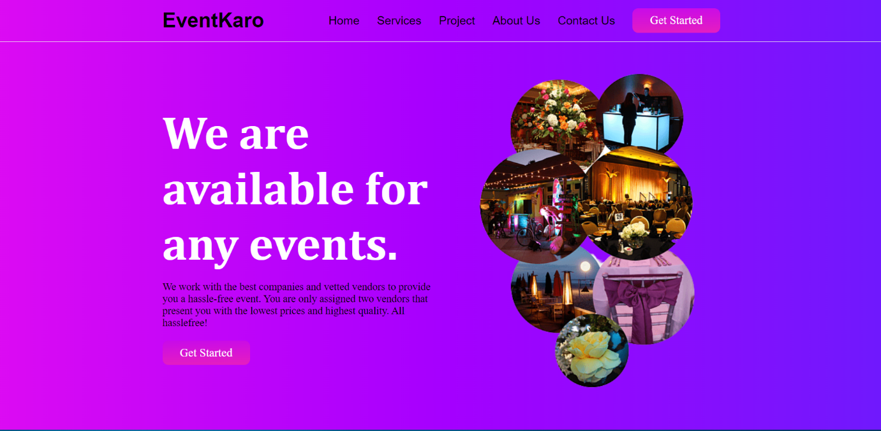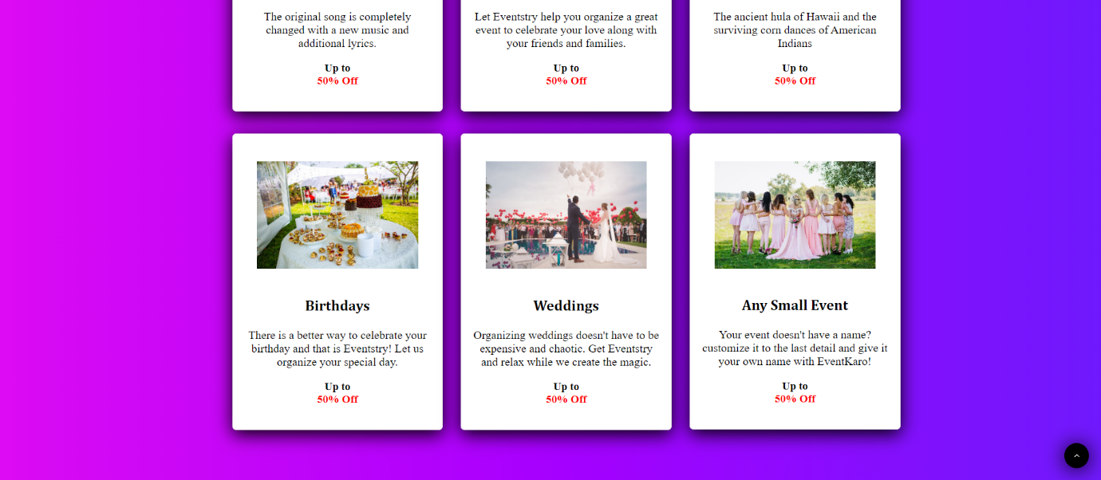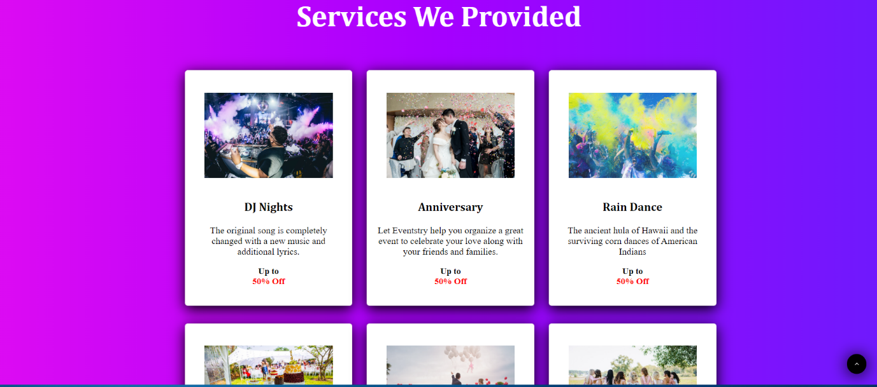

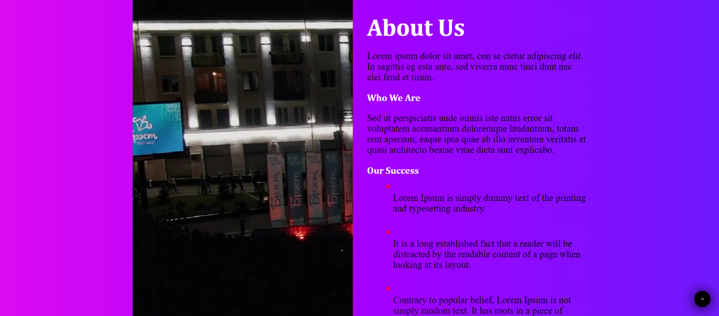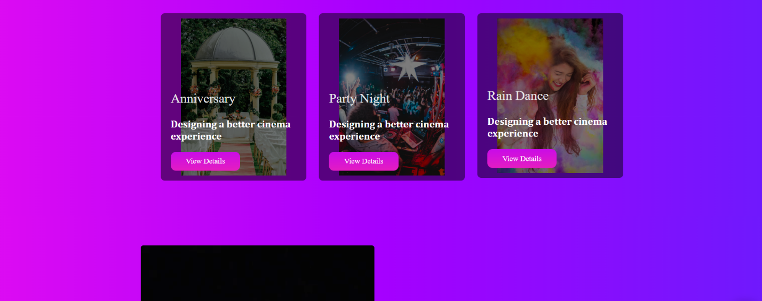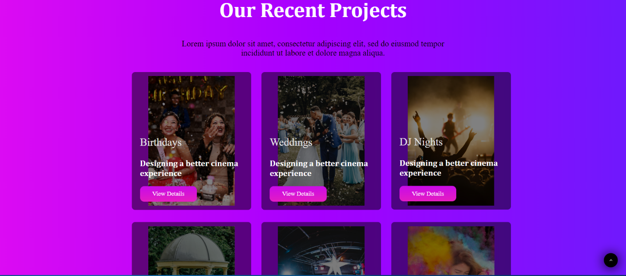

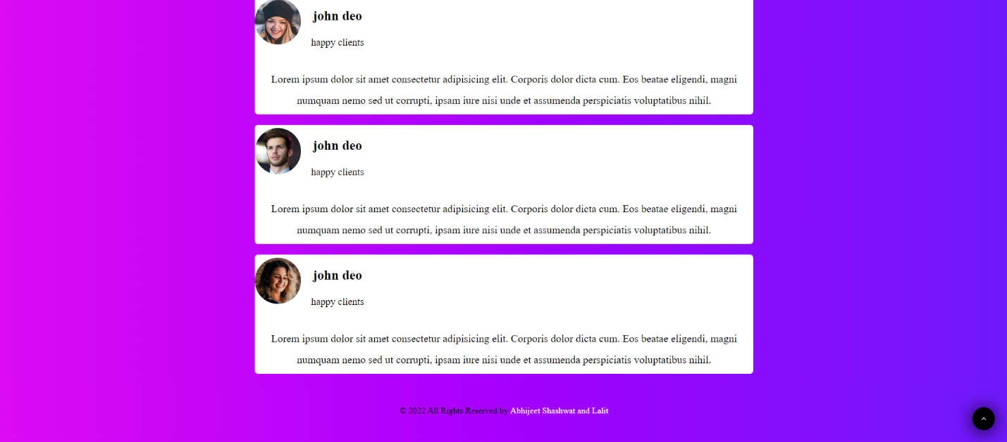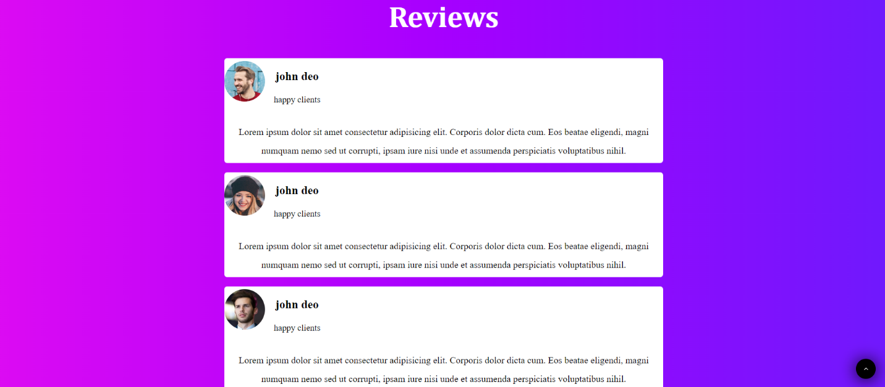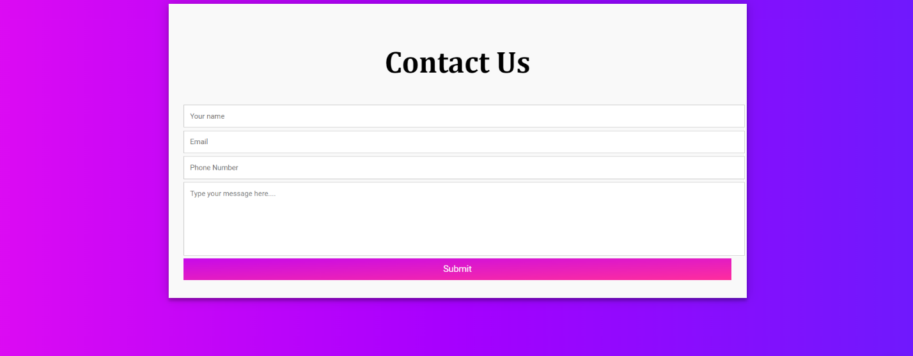

# 

### **Future Prospects in Event Management-**

Nowadays, there is a requirement for an event manager in almost every field like in corporate sector, hotel industry, tourism, fashion industry, film and media industries, social events etc. the talented youngsters can either work as a professional or set up his/her own business. Professionals in this field also get the opportunity to showcase their talent at international levels where delegates from our country participate in cultural festivals and exchange programs, trade shows, conferences, exhibitions, corporate events and so on. A successful event manager can earn in lakhs and cores. So, the demand for creative and talented event managers is never ending.

# CONCLUSION

Event management is a glamorous and exciting profession which demands a lot of hard work and dynamism. As the name suggests, it means conceptualizing, planning, organizing and finally executing an event. The event could be of any type - musical show, concert, exhibition, product launching etc. This industry is just eight years old in India, but holds a lot of promise for expansion. It offers enormous scope for ambitious young people.

Event management is the planning and implementation of events, large and small that meet the marketing goals of an organization. Event management is an area that is growing rapidly, and is expected to have a better growth rate in the next decade. Typical events organized by professional event managers include product launches, parties, sponsored events, sporting events, competitions, concerts and festivals, fundraisers, trade shows, corporate open days, seminars and tours.